Home Learning
Week beginning: 11th May 2020

Here are our learning topics for the week:
English: Phonics and Making Predictions
Maths: Partitioning Sets/Ways to make numbers
Gaeilge: An Teilifís (The Television)
Drama: Drama based on Peepo story
Whole-school event: Well-being Fortnight

Please log in to the Seesaw app and try it out if you haven’t already done so. We are asking you to send us one piece of work each week. Try sending it to us using Seesaw. If that’s not easy for you, not to worry. We hope to iron out any difficulties over the coming weeks.

Monday:
1. English - Speaking and Listening: Please go to Seesaw to see a video of a ‘Morning Meeting’. This is how we start every day in school.
2. English - ‘oi’ sound: Revise the sound and the action. Please go back to our website to see a PowerPoint based on the ‘oi’ sound. Identify words that begin with or contain the ‘oi’ sound. The children can try to read the following words: coin, coil, soil, joint. We have included a worksheet below based on the ‘oi’ sound.
3. Maths- : Partition sets. Go back to the website to see a video on using partition sets. Choose 1 object and place the object into the partition set. Can you write the number bond to match your set? Can you put the object into the partition set a different way? Use the partition set below or make your own. You will need the partition set each day for Maths this week.
Go back to the website for a link to a Maths game about counting.
4. Gaeilge: Our topic for the month is An Teilifís (The Television).
Please refer to the website for a PowerPoint presentation containing the relevant vocabulary for Monday and Tuesday. This learning is spread out over two days. Click on the speaker icon to hear recordings of the vocabulary pronounced correctly. We have also included the words from last week for your child to revise. On the PowerPoint, you will also find some listening activities and a poem from last week for your child’s enjoyment.
Below is a table of the new vocabulary on this topic for the week.
Fear grinn  (Clown) | Ag súgradh  (Playing)
Ag canadh  (Singing) | Seomra suí  (Sitting room)
5. Well-being Fortnight: Go to the Well-being Fortnight page for today’s activity!

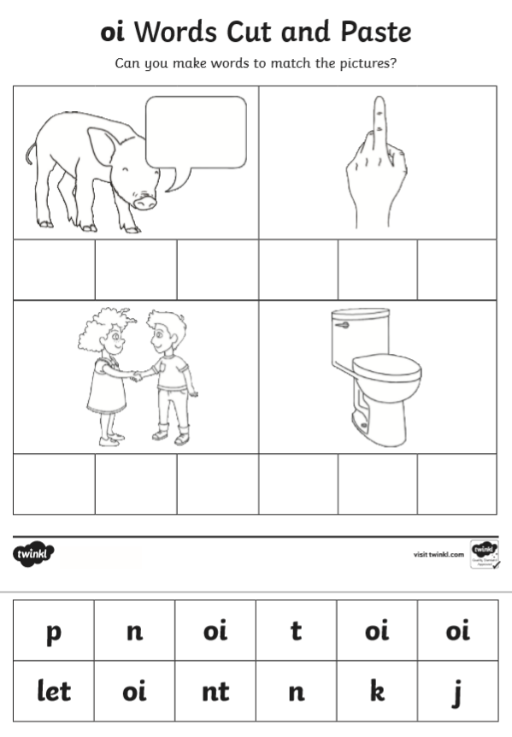

Tuesday:
1. English - Speaking and Listening: Please go to Seesaw to see a video of a ‘Morning Meeting’. This is how we start every day in school.
2. English - op word family: Think of some words that belong in the ‘op’ word family (hop, stop, mop, top, etc.). Your child can try to write a list of -op words. There is a worksheet below to practise -op words.
3. Maths- : Partition sets. Choose 2 objects and place the objects into the partition set. Can you write the number bond to match your set? Can you put the objects into the partition set a different way? Use the partition set from yesterday or make your own.
Go back to the website for a link to a Maths game about counting.
4. Gaeilge: Please refer to Monday’s activity above.
5. Well-being Fortnight: Go to the Well-being Fortnight page for today’s activity!

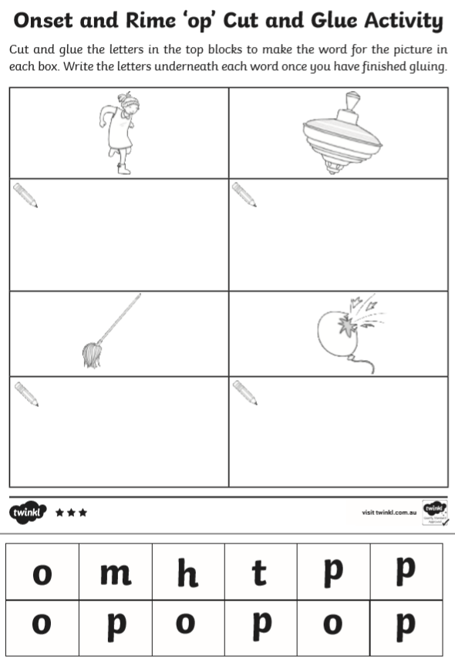Wednesday:
1. English - Speaking and Listening: Please go to Seesaw to see a video of a ‘Morning Meeting’. This is how we start every day in school.
2. English- Making Predictions: This week, you will be learning about making predictions. Do you know what “prediction” means? Discuss this at home.

Take some time to look at the images below. These images outline how and when we can make predictions. Notice that the child in the picture is using their fingers to create a “p”. This means they have a prediction, or a guess, to make.

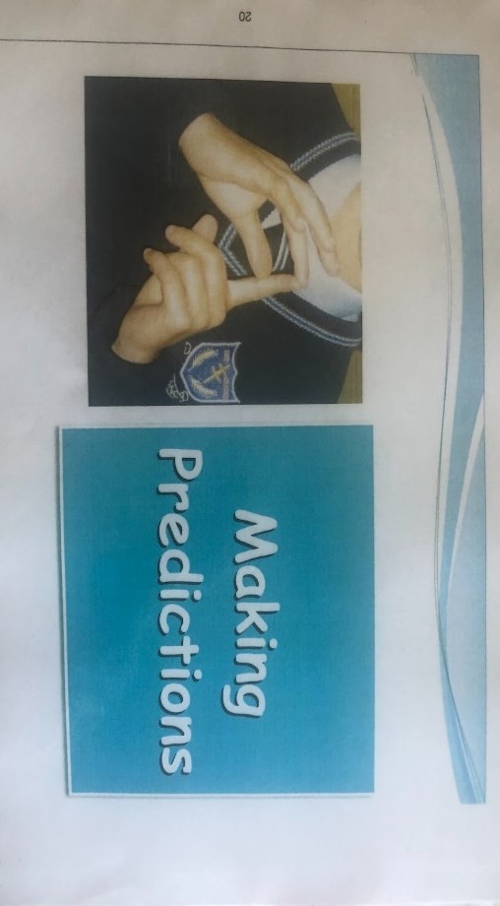

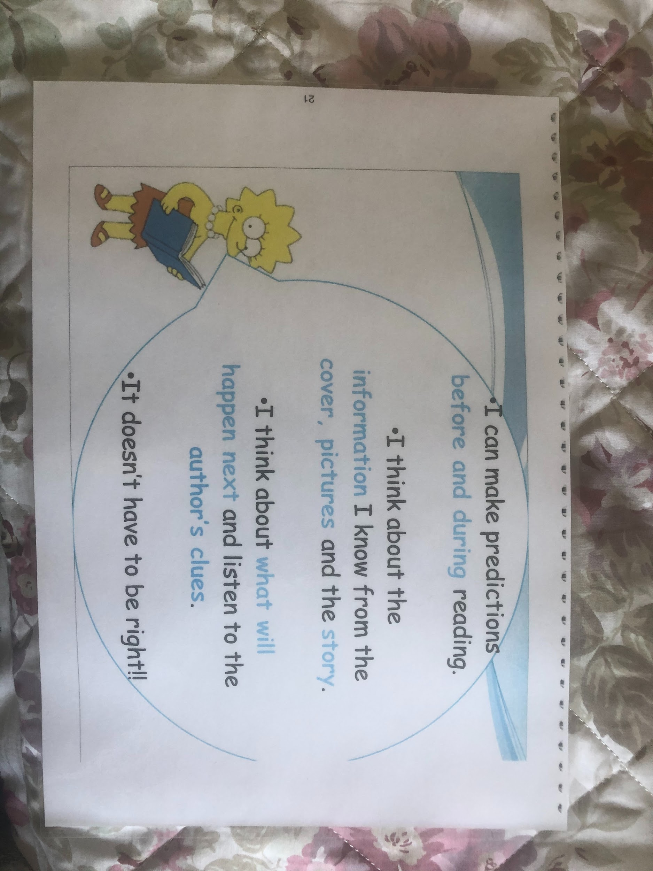

Think about making predictions when reading the story Peepo!
- By just looking at the front cover, we could make a prediction about what the story will be about.
- As we read the story, we can make predictions about what the baby sees. Then, we read on to see if our prediction was correct (it doesn’t have to be!)
We can have fun making predictions! Go to Seesaw for today’s activity.

3. Maths- : Partition sets. Choose 3 objects and place the objects into the partition set. Can you write the number bond to match your set? Can you put the objects into the partition set a different way? Use the partition set from Monday’s activity or make your own.
Go back to the website and you will find a link to a Maths game. Select ‘Ways to Make 3’ today.

4. Drama: Shake out your sillies before your drama lesson. For eight beats, shake out your right arm, then left arm, right leg/foot, then left leg/foot. Count the eight beats aloud.
This week’s Drama activities are based on the story Peepo. Please refer back to the website for the read aloud video of Peepo for today’s activity. Alternatively, if you have the book at home, an adult can read it aloud to you.
- Imagine that you are the baby in Peepo!
- Think about how a baby might be- their posture, behaviour, facial expression(s) etc. Think about how you are feeling in the present moment.
- Play the read aloud. Pause it at different points if necessary.
- Respond to the story, as the baby, through your body and your facial expression(s). Try to express how the baby was feeling throughout the story. Try not to use your voice.
- Example- the baby might feel happy/comforted/peaceful at seeing his grandma and the tassels blowing on her shawl. How can you convey this feeling using your face and body?
- Example- the baby might feel angry/excited/frightened at seeing the dog in the doorway that shouldn’t be there. How can you convey this?
Have some fun with this! There is no right or wrong way to do it! Perhaps other family members can join in too.

5. Well-being Fortnight: Go to the Well-being Fortnight page for today’s activity.

Thursday:
1. English - Speaking and Listening: Please go to Seesaw to see a video of a ‘Morning Meeting’. This is how we start every day in school.
2. English - Making Predictions: Revise what it means to make a prediction. Please refer to the website to listen to part of the story of The Tiger Who Came to Tea. Try to make predictions about what will happen next. Let your family know that you have a prediction to make by forming a “p” with your fingers. Discuss your prediction. Tune in next week to see what happens next!
3. Maths- : Partition sets. Choose 4 objects and place the objects into the partition set. Can you write the number bond to match your set? Can you put the objects into the partition set a different way? Use the partition set below or make your own.
Go back to the website and you will find a link to a Maths game. Select ‘Ways to Make 4’ today. Go to Seesaw to see today’s activity..
4. Drama: As above, shake out your sillies for eight beats before starting today’s drama activity. Extend this warm up with a brief game of Feelings Faces-
- List some feelings (happy, sad, angry, excited etc.) and express this feeling on your face.
- Example- for happy, you might have a wide smile and bright eyes.
- Example- for sad, you might be frowning, have pursed/quivering lips and be looking down at the ground
Please refer to the website for the read aloud of Peepo. You will find it under Wednesday’s resources. Today’s activity will be similar to yesterday’s but this time, you can use your voice!
- Play the read aloud (you don’t need to play the entire story as using your voice may mean that it will take longer to respond).
- Remember, you are imagining that you are the baby and you are responding to all of the things you see.
- You are using your face, body and voice to express how you are feeling.
- Think about a baby’s voice- how does it sound? How might your voice change as your feelings change?
Reminder- there is no right or wrong way to do this! Enjoy!

5. Well-being Fortnight: Go to the Well-being Fortnight page for today’s activity!

Friday:
1. English - ‘ue’ sound: Revise the sound and the action. Please go back to our website to see a PowerPoint based on the ‘ue’ sound. Identify words that begin with or contain the ‘ue’ sound. The children can try to read the following words: cue, rescue, fuel. We have included a worksheet below based on the ‘ue’ sound.
2. Maths- : Partition sets. Choose 5 objects and place the objects into the partition set. Can you write the number bond to match your set? Can you put the objects into the partition set a different way? Use the partition from Monday or make your own.
Go back to the website and you will find a link to a Maths game. Select ‘Ways to Make 5’ today.
3. Drama: For the last time this week, shake out your sillies for eight beats before starting your activity. You are super shakers now!
Today’s activity is also based on Peepo. You will be focusing on one character that is not the baby. Please refer to the website for a read aloud video of Peepo. Alternatively, if you have the book at home, you can use it for this activity.
- Choose one picture from the story that you love and pause the video on it.
- Take a moment to look at the picture. What do you see?
- Choose one person/character from the picture and imagine that you are them.
- Think about how that character is feeling in the picture (you can make it up!)
- Think about their role and their relationship to the baby and to the others characters in the picture (you can make this up too!)
- Think about how they are responding to what is happening around them. What do they see? What do they hear? Do they like where they are?
- Example- you might choose to be the baby’s grandma sitting on the bench in the park. She might be feeling happy as she enjoys knitting and being outdoors. She is also happy to see so many children playing in the park and that there is a police officer there to help. She hears cars and buses driving by. She doesn’t like the sound of traffic etc.
Have fun with this activity and with the chance to be a different character!
Remember- there is no right or wrong way to do it!
4. Well-being Fortnight: Go to the Well-being Fortnight page for today’s activity!

Bonus activity: Caitríona will be hosting an assembly for you on Zoom today. Try to join in if you can - she would love to see you! If you can’t make it, you can still practise your sign language skills with Caitríona here.

